**CONTROLLING IOT DEVICES THROUGH PC**

**PROCEDURE:**

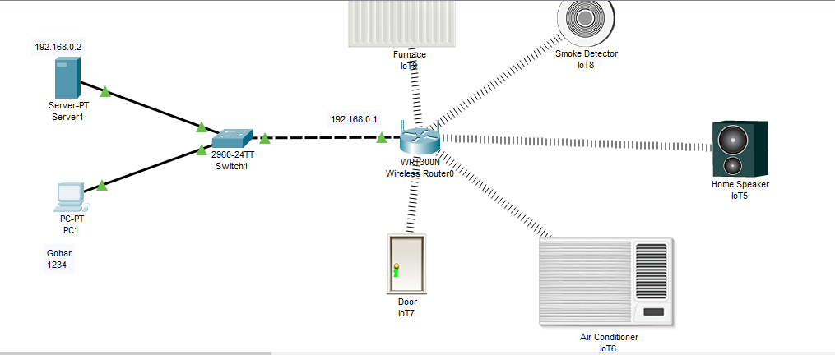

1. Step all devices on cisco as given in above picture
2. Then note the IP of wireless router and set it as gateway of server and then assign IP to server
3. On services portion of server goto AAA and make a complete setup as given below  
   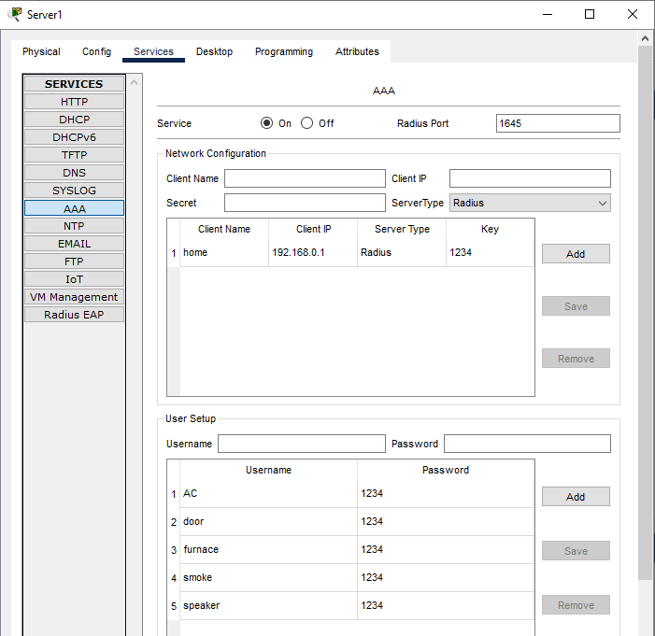

1. Then goto router and do the following configuration

1=>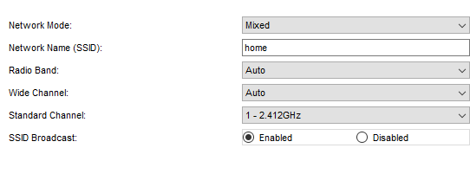

2=>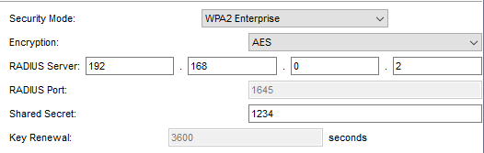

1. Then on each IOT device do following configuration  
   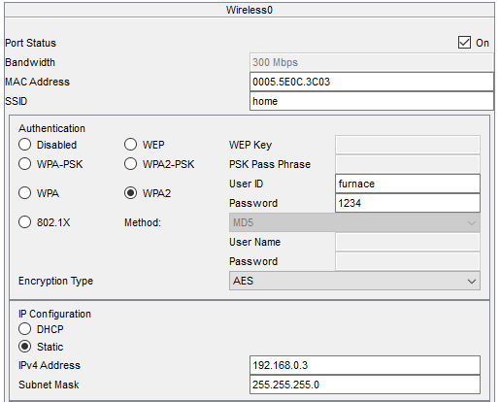
2. After that your devices will be connected to router but not linked with PC  
     
   Now click on PC and dynamically assign IP to it and login to server by following method
   1. Goto web browser and write server IP on browser
   2. then make login credential there
3. Now on each device goto remote server and connect it with your PC  
   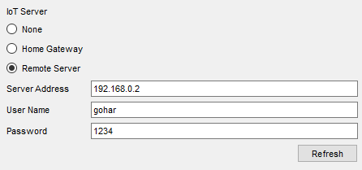
4. Now PC have access to control all IOT device  
   